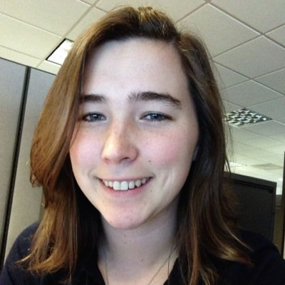“Kaylee Kean, Managing Editor, senior journalism major, broadcasting minor

I have been writing for The Oakland Post since September 2013, and became Managing Editor around March 2014. I love writing and learning, I love my job and the people I have met through it, I love chocolate, and I love OU!

Contact me at: [managing@oaklandpostonline.com](mailto:managing@oaklandpostonline.com" \t "_blank)."

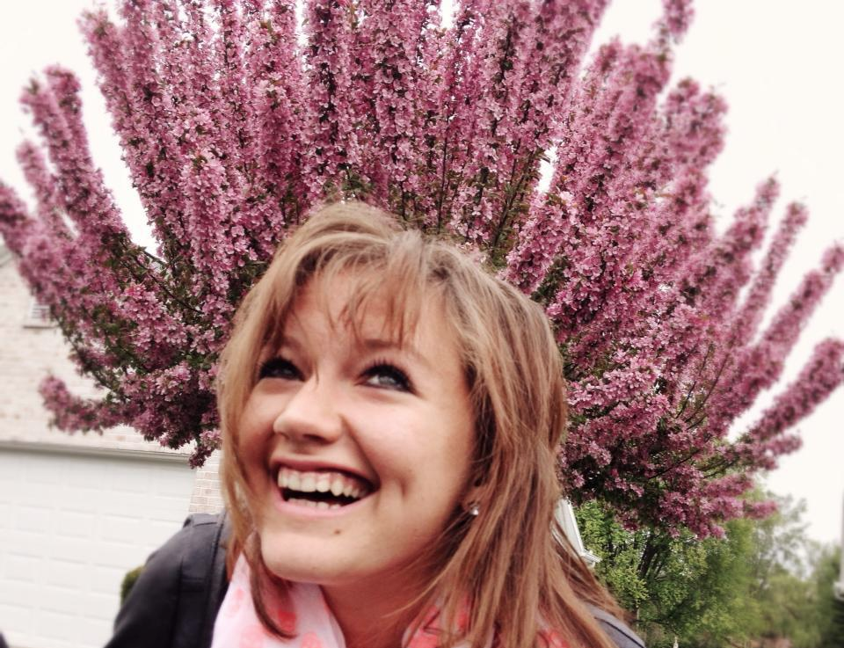

“Ali DeRees, Campus & Administration Editor, senior journalism major

I am a journalism major and Spanish minor here at OU. I love running and anything automotive related. I truly love my job, it is the most rewarding experience I've had at college thus far!

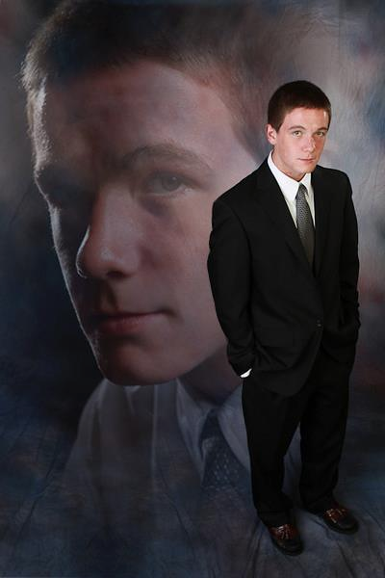

Contact me at: [apderees@oakland.edu](mailto:apderees@oakland.edu).”

“Jackson Gilbert, Sports Editor, senior political science major

I’m the Sports Editor at The Post. I can’t play any sports very well so I write about them instead.

Contact me at: [jjgilber@oakland.edu](mailto:jjgilber@oakland.edu).”



“Haley Kotwicki, Chief Copy Editor, senior English major

I have been editing, writing and photographing for The Oakland Post since May 2012.  I seem to be the mother bear of our staff, which I take somewhat seriously.  My passions outside writing are rescuing animals and painting.

Contact me at: hekotwick@oakland.edu “

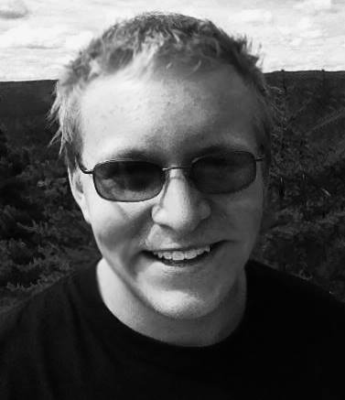

“Sean Miller, Reporter and Photographer, senior journalism major

You'll only find me around these parts during the school year. I hail from Northern Michigan where it's winter ten months out of the year and people hunt deer with their cars. I’ve been writing for the Oakland Post since April 2014 and love contributing to a great news organization that OU offers.

Contact me at: [semille3@oakland.edu](mailto:semille3@oakland.edu" \t "_blank)”



“Sélah Fischer, Reporter, senior journalism major, PR minor

"Being a new reporter I already love working for The Oakland Post! I love writing, traveling and meeting new people. I truly believe a job you love is no job at all, and that's exactly how I feel about working with the Post!

Contact me at: [scfische@oakland.edu](mailto:scfische@oakland.edu).”

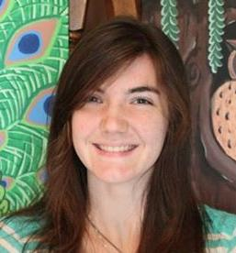

"Dani Cojocari, Photographer, creative writing major

I started working for The Oakland Post in May 2014. Although I love taking photographs, my passion is for writing fiction and reading. One day, I hope to publish a novel that everyone will enjoy.

Contact me at: [dmcojoca@oakland.edu](mailto:dmcojoca@oakland.edu" \t "_blank)"

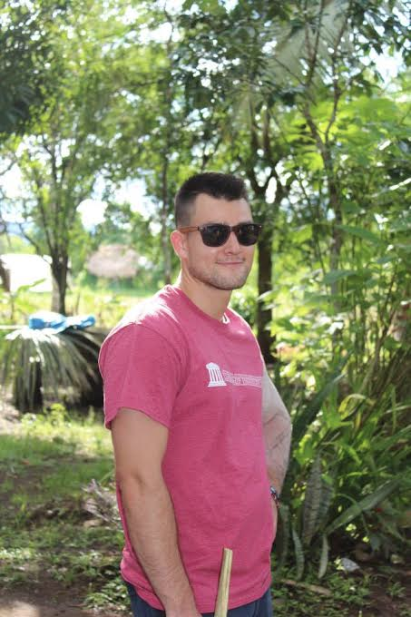

“Phillip Johnson, Reporter, senior finance major

Since starting for The Oakland Post, Phillip has a new found appreciation for journalism and news media. Outside of writing Phillip enjoys kayaking, yoga and helping people.

Contact me at: [pajohns4@oakland.edu](mailto:pajohns4@oakland.edu).”

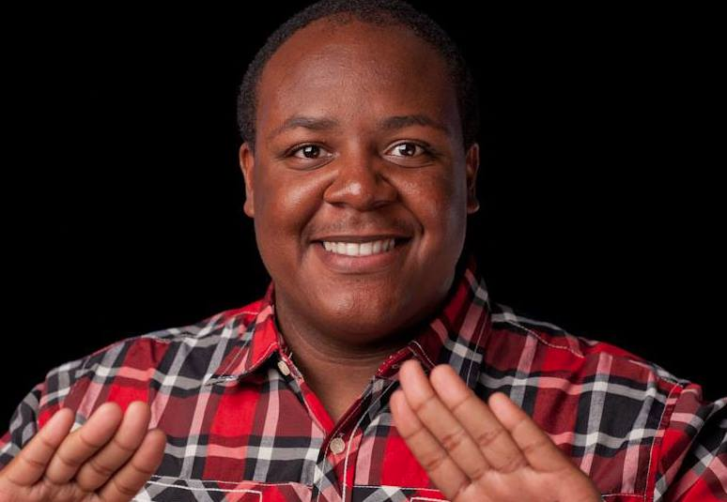

“Arkeem Thomas-Scott, Promotions/Social Media Manager, senior communication major

"This is my first year working for The Oakland Post. I am also involved with the Student Program Board and with Athletics. I love watching movies and listening to new artists while I'm on the go.

Contact me at: [ascott24@oakland.edu](mailto:ascott24@oakland.edu).”



“Jessie DiBattista, Reporter, freshman psychology major

My name is Jessie, I am a Reporter, this is my first year working for The Oakland Post, and I have loved every minute of it! I am a Freshman and I am excited to continue my adventure at OU!

Contact me at: [jldibattista@oakland.edu](mailto:jldibattista@oakland.edu" \t "_blank).”

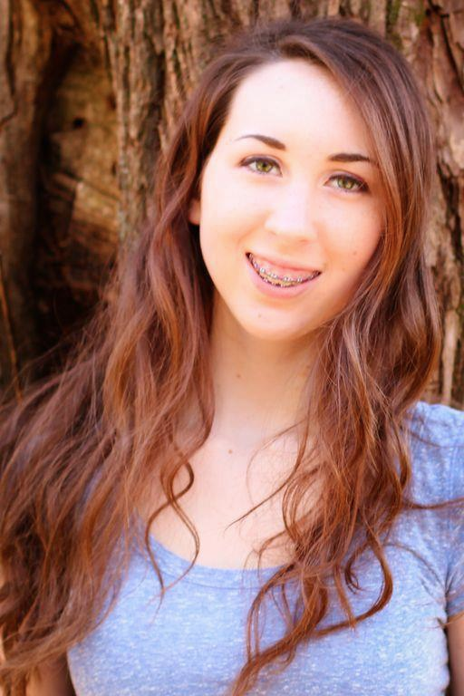 “Megan Carson, Copy Editor, freshman  
  
Megan is a freshman and new member to the Oakland Post staff. She gained knowledge and experience in writing and layout from her yearbook class at Oxford High School. Her goal is to help maintain the Oakland Post's reputation as well as to improve it. When she is not working on the newspaper or in class, Megan enjoys hanging out with friends, eating Oreos, and watching Netflix.

Contact me at: [mecarson@oakland.edu](mailto:mecarson@oakland.edu).”

**NEED: Oona, Kaleigh J., Josh Soltman, Nicollete Brikho, Andrew Wernette, Jasmine French, Salwan Georges, Jake Alsko.**